**Defect ID:** Bug_Login_001

**Title:** Enter valid email and password in login page but Login failed.

**Description:** In Login, we use valid email and password but system display error message: “Warning: No match for E-Mail Address and/or Password.”

**Steps to Reproduce:**

1. launch Browser

2. Go to Login page

3. Type Email

4. Type password

5. Click Login Button

**Test Data:**

Email: mail@mail.com

Password: 123456

**Actual Result:**

system display error message: “Warning: No match for E-Mail Address and/or Password.”

**Expected result:**

Successfully login and open dashboard.

**Attachment:**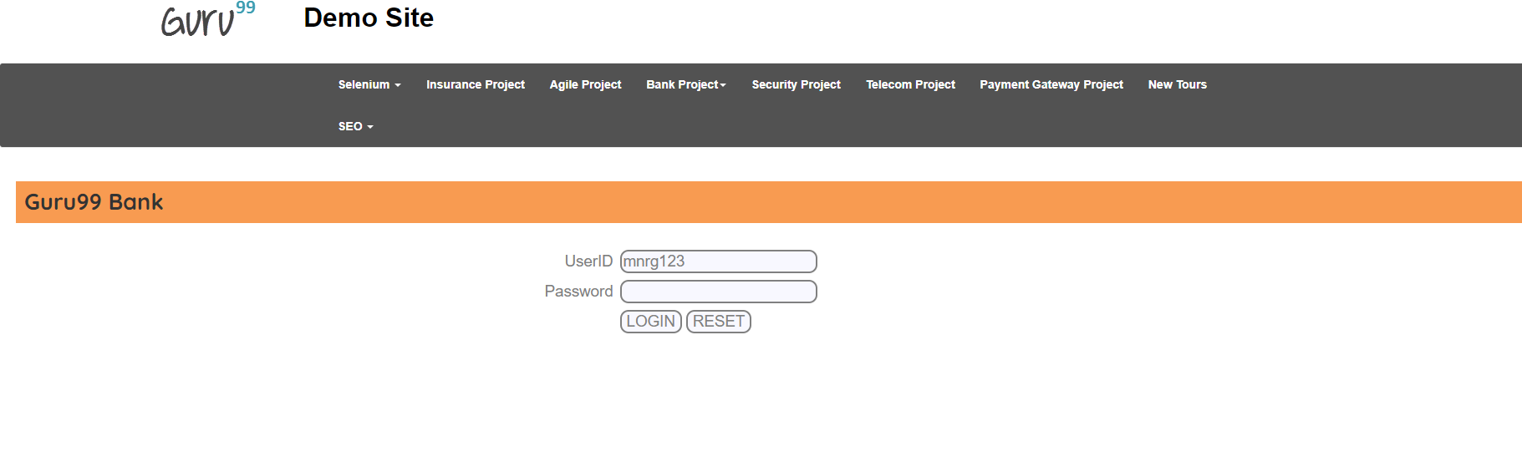

**Priority: High/Medium/Low**

High

**Severity: Major/Minor/Low**

Major

**Environment:** Windows 10, Chrome Version 99.0.4844.51

**Defect ID:** Bug_CustomizeStatement_001

**Title:** Enter Number of Transaction Customize Statement page but failed.

**Description:** In Customize Statement, we use Number of Transaction more than 5, but system display successfully done transaction: “Go to another don’t show any error massage like more than 5 transactions are not allow.”

**Steps to Reproduce:**

1.Launch Browser

2.Go to ABC bank manager login page

3.Go to Customize Statement page

4. Type Number of Transaction

**Test Data:**

Type Number of Transaction: 7

**Actual Result:**

system display error message: “Go to another don’t show any error massage like more than 5 transactions are not allow.”

**Expected result:**

Show massage "Can't transaction more than 5 account"

**Attachment:**

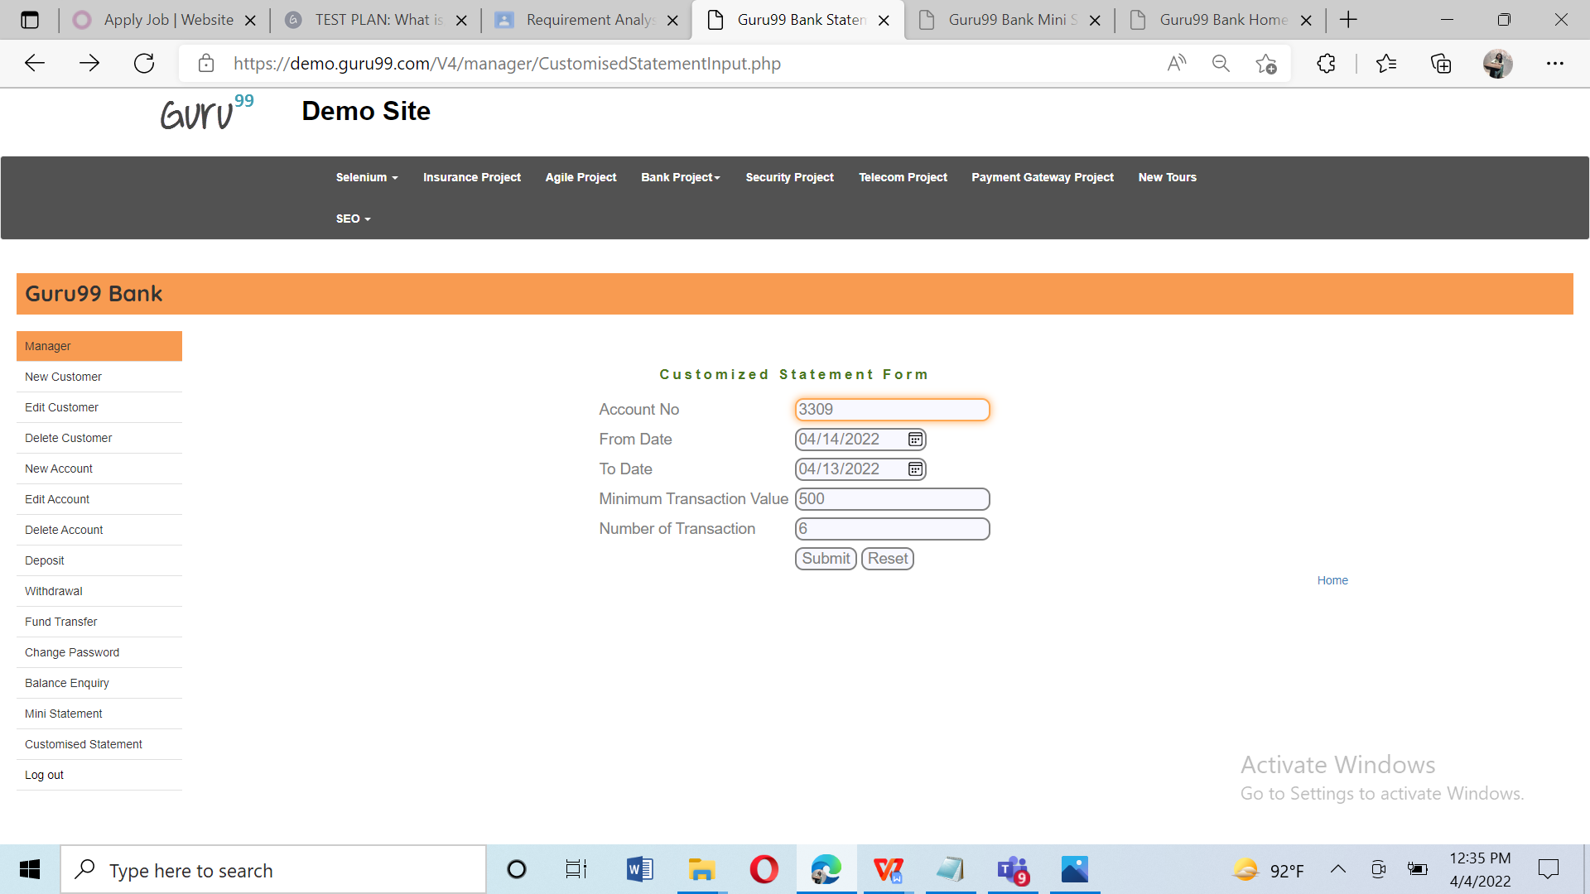

**Priority: High/Medium/Low**

High

**Severity: Major/Minor/Low**

Critical

**Environment:** Windows 10, Chrome Version 99.0.4844.51

**Defect ID:** Bug_BalanceEnquire_001

**Title:** Enter valid AccountNo in Balance Enquire page but Balance Enquire failed.

**Description:** In Login, we use valid email and password but system display error message: “Please fill all fields.”

**Steps to Reproduce:**

1.Launch Browser

2.Go to ABC bank manager login page

3.Go to Balance Enquiry page

4. Type Account No

5.Click Submit Button

**Test Data:**

Account No: 3309

**Actual Result:**

system display error message: “Please fill all fields.”

**Expected result:**

Successfully login and open dashboard.

**Attachment:**

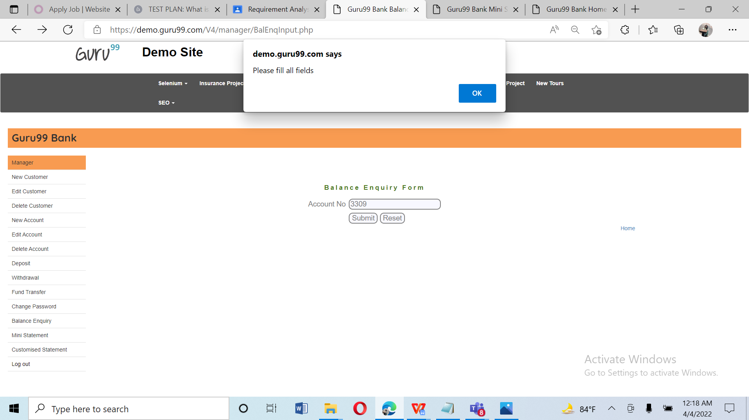

**Priority: High/Medium/Low**

High

**Severity: Major/Minor/Low**

Major

**Environment:** Windows 10, Chrome Version 99.0.4844.51